

Project Scope Management

PJM 6005

Assignment 1

Title: Project Feasibility Study

Rahu Iyer

Professor Name: Ann-Marie Dunphy

**CONTENTS:**

1. MANUFACTURING FACILITY (CASE 1)

1.1 Purpose…………………………………………………………………………..3

1.2 Executive Summary……………………………………………………………..3

1.3 Background……………………………………………………………………...3

1.4 Business Analysis……………………………………………………………..…3

1.5 Projected Potential Risks………………………………………………………...4

1.6 Potential Solutions………………………………………………………..……...4

1.7 High Level Timeline……………………………………………………………..5

1.8 High Level Cost…………………………………………………..……………...6

1.9 High Level Benefit Assessment………………………………………………….7

1.10 Impact to Business……………………………………………………………...7

2. WIRELESS WAREHOUSE INITIATIVE (CASE 2)

1.1 Purpose…………………………………………………………………………...8

1.2 Executive Summary……………………………………………………………...8

1.3 Background………………………………………………………………………8

1.4 Business Analysis………………………………………………………………..8

1.5 Projected Potential Risks……………………………………………………..….9

1.6 Potential Solutions……………………………………………………………….9

1.7 High Level Timeline……………………………………………………………..10

1.8 High Level Cost………………………………………………………………….11

1.9 High Level Benefit Assessment……………………………….………………....11

* 1. Impact to Business…………………..………………………………………….12

RATIONALE ………………………………………………………………………………..13

APPENDICES

List of Figures ……………………………………………………………………… 14

List of Tables ……………………………………………………………………….. 14

REFERENCE ………………………………………………………………………………. 15

**1. MANUFACTURING FACILITY (CASE 1)**

**1.1 Purpose**

The project feasibility study serves many purposes:

1. Meet customer demands
2. Identify a new site for the manufacturing facility
3. Estimate the budget of the project in order to complete it within a year
4. Build a large, state-of-the-art manufacturing facility
5. Obtain project approval from sponsor.
6. Foundation for Project Charter

**1.2 Executive Summary**

The client is a billion-dollar manufacturer and marketer of beauty, personal care, and household products around the globe. The organization desires to expand its global appeal soon and therefore is in search of a new manufacturing facility which has 475,000-square-foot area with state-of-the-art technology fully functional within a year.

**1.3 Background**

The cosmetic giant has decided to undertake another manufacturing facility to keep up with increasing customer demands and maintain competitiveness at the same time. The search for location of the facility was conducted in 28 states of the United States. They modified their search to have a large facility with advanced technology to ensure that their products are of optimum quality.

**1.4 Business Analysis**

A new manufacturing facility has the potential to align with the strategic goals of the organization, which is obtaining a wider global recognition and increase profitability by meeting the rising demands. All aspects of this highly complex, enterprise-level strategic initiative will be orchestrated as a coordinated effort to enhance the project’s success rate.

**1.5 Projected Potential Risks to the Business**

1. The project is very ambitious and slightly unrealistic, unable to meet the expected outcome with the estimated schedule.
2. Co-ordination would be difficult as it is a complex, large-scale project with many activities, delaying the project and inefficient utilization of resources.
3. Probability for confusion or misinterpretation of project objectives among employees is high due to the project size and complexity; eventually leading to mistakes, thereby delaying the project.

**1.6 Potential Solutions and Analysis for Options**

1. Establish a kick-off meeting with all key stakeholders to set project constraints and obtain a more realistic target.
2. Employ lean manufacturing principles to translate the corporate policies to fit the new manufacturing culture.
3. Weekly status report meetings to discuss the issues faced and how to get rid of them.
4. Hire experienced project team members so that room for errors reduce.
5. Assign team leaders to ensure communication is simpler and more effective within the team.

**1.7 High Level Timeline**

The project is divided into three stages:

1. Stage I-Initiating and Planning Phase (74 days)
2. Stage II- Execution Phase (140 days)
3. Stage III- Monitoring, Controlling & Closing Phase (47 days)

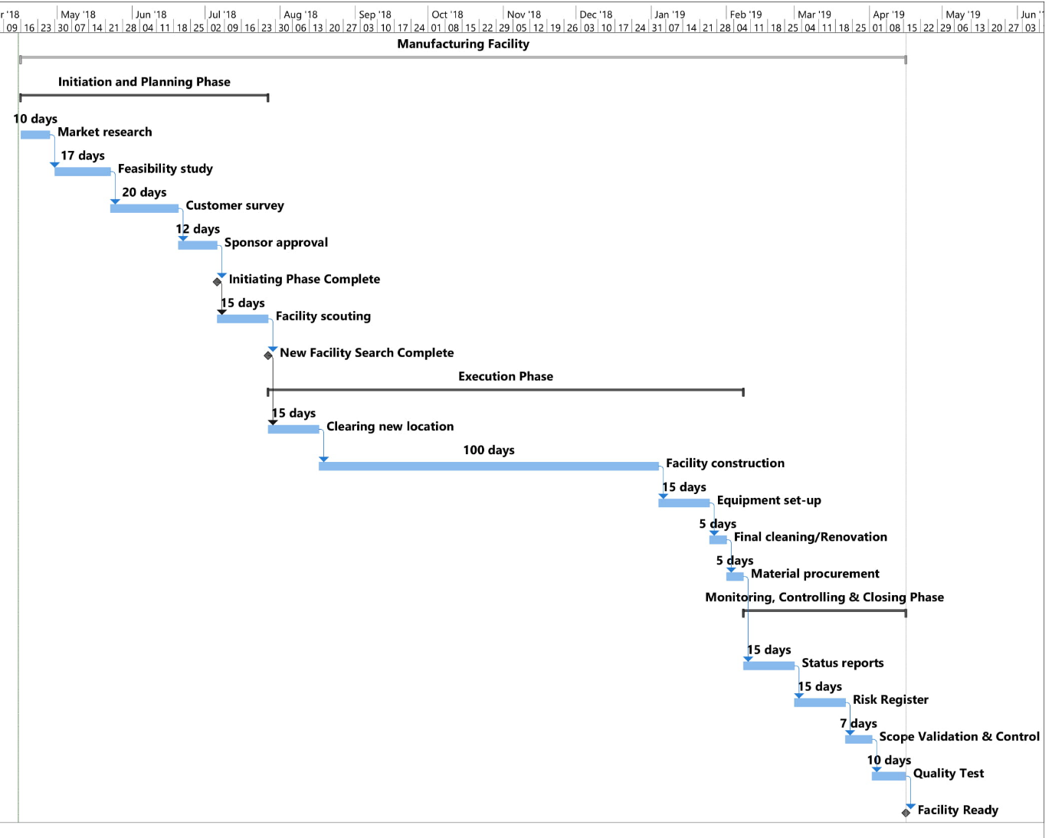

Fig. 1. High Level Timeline (Case 1)

The total project duration is 261 working days (a calendar year).

**1.8 High Level Cost**

|  |  |  |
| --- | --- | --- |
| Sr. No. | Name | Cost (USD) |
| 1 | Real estate Consultant fee | 100,000 |
| 2 | Facility Rent | 2.5 million/month (30 million/year) |
| 3 | Equipment | 3 million |
| 4 | Labor | 17 million |
| 5 | Materials/Concrete | 1.6 million |
| 6 | Electricity | 2.75 million |
| Annual Budget | | 54.45 million |

Table 1. High Level Cost (Case 1)

Notes: a) The consultant charges roughly about USD 75- 150/hour (Poelman, 2015). About half-a-month (1000 hour) consultation would charge about USD 100,000 @ 100/hour.

b) Rent in San Francisco: USD 2,500,000/month (It would not be possible to purchase a 475,000 sq. ft. area with a budget of USD 60 million. Therefore, renting the place is more practical. California has a lot of demand for beauty products. Setting up business here would be profitable. The rent for a 500 sq. ft. home in San Francisco, CA is estimated to be 2,674 USD/month (Zillow). Extrapolating these results, it would cost the organization about 2.5 million USD/month or 30 million/year.

c) Equipment, labor and electricity costs have been assumed.

d) Material value has been estimated by calculating the concrete required for building the facility in 450,000 sq. ft. area out of the total 475,000 sq. ft. area. The concrete required for 450,000 sq. ft. area (600 ft. x 750 ft.) with 1 feet thickness is 16,667 cubic yards according to CEMEX, a leading website for estimating quantity of raw materials. The Concrete-Network website states that the cost of 1 cubic cement yard is USD 108. Therefore, the material cost is approximately 1.8 million USD.

**1.9 High Level Benefit Assessment**

|  |  |
| --- | --- |
| Benefit | Impact |
| Increased revenue opportunities | High |
| Increased profitability for products and services | High |
| Increased cash flow opportunities | High |
| Increases shareholder value | Medium |
| Promotes company reputation or market position | High |
| Allow the company to be more competitive | High |
| Promotes company values and strategic decisions | High |
| Increased quality | High |
| Improved Communication | High |

Table 2. High Level Cost (Case 1)

**1.10 Impact to Business (Value Proposition)**

1. Lean manufacturing capability enhanced within the organization
2. The project was fully functional within a year.
3. The company realized almost 4 million, which is 33% of their projected return within 5 months, seven months ahead of schedule.
4. Foundation for integration of new, upcoming manufacturing units into the facility.

**2. WIRELESS WAREHOUSE (CASE 2)**

**2.1 Purpose of the Feasibility Study**

The project feasibility study serves many purposes:

a) Documents the challenges faced by the warehouse

b) Provides alternatives to overcome the challenges

c) Provides an estimated budget and duration for implementation of the initiative

d) Contains all information to obtain the sponsor’s decision

e) Serves as basis for Project Charter

**2.2 Executive Summary**

The client is well-established for supplying highly efficient turbine-driven gas compression, oil pumping and power generation packages for onshore and offshore applications worldwide. The large-scaled company relies on their employees for various material management functions. The organization turned to automation in search of a solution to enhance the North America’s warehouse efficiency and productivity. But soon, the organization realised that they did not have the necessary project management expertise to complete the initiative. PM Solutions took control of managing the project thereafter, almost after two-third of the project was underway.

**2.3 Background**

The organization receives many shipment orders from different countries; maintaining records and tracking the shipment has become troublesome. Hiring more employees led to confusion, errors which impacted the delivery schedule of these power generation packages. Additionally, it increased the logistics costs and expenditure on labor costs which had a negative impact on the company’s profit margins. Based on the conclusion of an analysis conducted by the company, technology was found to be the most suitable substitute manual labor.

**2.4 Business Analysis**

A technological platform like SAP’s Supply Chain Management software would provide real-time supply chain visibility through transfer of the data from the warehouse floor directly into the software without going through manual counting and recording process. Automation would not only improve organization’s accuracy but also reduce overhead costs. Subsequently, delivery speed would be further enhanced by integrating radio frequency and SAP within the warehouse.

**2.5 Projected Potential Risks to the Business**

1. RF requires a lot of advanced devices to ensure smooth functioning. A defect in any of the devices could bring the entire warehouse operations to a standstill.
2. SAP console is a pre-requisite for the RF-SAP integration. The console consists of 4 components, one of which is the RF Access Point that permits wireless Ethernet. A dysfunction with this would result in data being stuck at one end of the terminal.
3. Unstable wireless connection can hamper the productivity of the integration and would delay activities and processes within the warehouse as all have been coordinated to be inter-dependent.
4. Privacy of the information is also at risk because the software’s information can be accessed in nearby areas.

**2.6 Potential Solutions and Analysis for Options**

1. Acquiring new, advanced and good quality devices from a reliable distributor is encouraged as it would reduce the device-related risks.
2. Obtaining high-speed internet connection from established network providers, keeping one network as a backup in case of improper connection.
3. Firewall can be installed to support the software’s security so that access is denied to third-party users and the information is confidential within the warehouse.

**2.7 High Level Timeline**

The project has been divided into three phases:

1. Initiation and Planning Phase (17 days)
2. Executing Phase(42 days)
3. Monitoring, Controlling & Closing Phase(28 days)

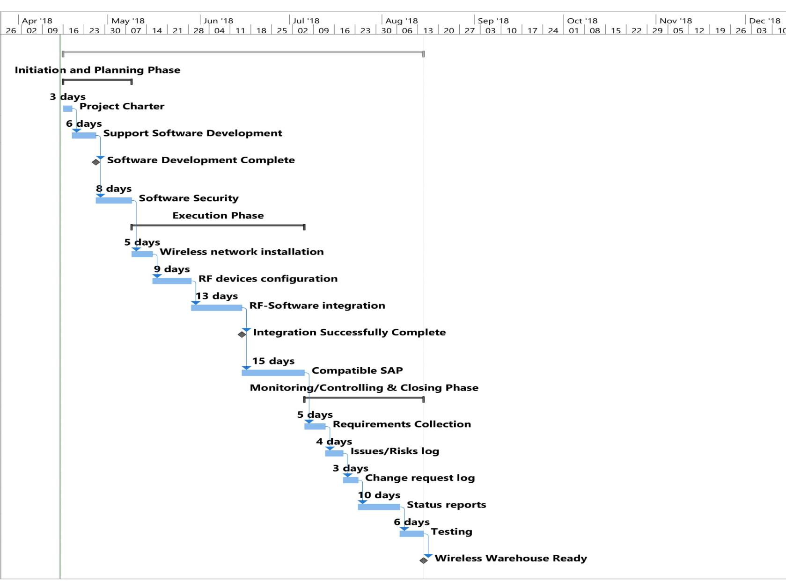

Fig. 2. High Level Timeline (Case 2)

The total project duration is 87 days.

**2.8 High Level Cost**

The following is provided for budgetary purposes only. It is based on the information provided so far and can be assumed to be +/- 25% accurate. A final detailed cost estimate will be provided at the end of the Project Planning Phase.

|  |  |  |
| --- | --- | --- |
| Sr. No. | Name | Cost (USD) |
| 1 | Professional SAP License | 3200 |
| 2 | 1000 feet CAT-6 cable | 250 |
| 3 | Installation | 500 |
| 4 | Wireless Connection | 900 |
| 5 | RF Support devices | 700 |
| Total Budget | | 5,550 |

Table 3. High Level Cost (Case 2)

Note: 1) The estimated value of SAP license has been taken from Aether Consulting.

2) Cost of cable, installation and wireless connection is obtained from Fixr. The value of wireless connection is USD 300/month; it is calculated as USD 900 to account for the three month project duration.

3) The cost of RF support devices has been assumed to be USD 700.

**2.9 High Level Benefit Assessment**

|  |  |
| --- | --- |
| Benefit | Impact |
| Increased revenue opportunities | High |
| Increased profitability for products and services | High |
| Expense reduction opportunities | High |
| Increased cash flow opportunities | Medium |
| Increases shareholder value | Medium |
| Promotes company reputation or market position | Moderately high |
| Increased productivity | Very High |
| Reduction in error rates | High |
| Simplifies procedures through ease of operation | Low |
| Reduce delivery time | High |
| Better tracking of shipment/orders | High |
| Improved accuracy | High |

Table 4. High Level Benefit Assessment (Case 2)

**2.10 Impact to Business (Value Proposition)**

1. The new RF solution was delivered on-schedule and 18% under-budget.
2. Improved inventory accuracy
3. Improved productivity
4. Faster time-to-market
5. Delivery speed was faster, reducing delivery time by 66% (from 24 hours to 8 hours).
6. Served as a foundation for the client’s initiatives in US and Europe.

**Rationale:**

It can be observed that although both projects are profitable. The cases are similar in the fact that these endeavours would decide the organization’s future course of action. A successful initiative would pave the way to initiate similar projects in future. I would choose manufacturing facility (Case 1) over the wireless warehouse initiative (Case 2) based on High Benefit Analysis.

Although the wireless warehouse has a very low-budget of just USD 5,550; the profit is limited. The reason being that the initiative would not improve the revenue/sales or manufacturing quality of the product, it would rather improve the working efficiency within the warehouse through the introduction of SAP software.

Firstly, the manufacturing facility is being established with a much better purpose- to serve more customers and for the improvement of product quality compared to the warehouse case intention of increasing shipment order’s accuracy, reducing errors and the error-related cost.

Secondly, consumer-based products are more consistent in performance of sales. According to the current trend of the consumer product, the manufacturing facility is a safer and better option because the organization’s current demand exceeds its supply and the manufacturing facility would help boost the organization’s sales, revenue and hence, profit. Case 1 is a strategic initiative- aligning the new facility with the organizational goals, versus Case 2, which is a remedial initiative- to fix errors and streamline the warehouse ordering process.

A faster delivery of shipment would definitely be beneficial but it would not guarantee more orders or more revenue; it is strictly a need-based supply market. On the other hand, the probability of reduction in sales of consumer goods is high, only if the quality of the product is hampered or becomes obsolete because of technological innovation. But, the manufacturing facility is being constructed to ensure that no compromise is being made on quality, therefore, chances of defects are very low, increasing the project’s success rate. Hence, the manufacturing facility is a more viable option among the two cases.

**Appendices**

* List of figures
  + Figure 1- High Level Timeline (Case 1- Manufacturing Facility)
  + Figure 2- High Level Timeline (Case 2- Wireless Warehouse)
* List of tables:
  + Table 1- High Level Cost (Case 1)
  + Table 2- High Level Benefit Assessment (Case 1)
  + Table 3- High Level Cost (Case 2)
  + Table 4- High Level Benefit Assessment (Case 2)

**Reference:**

Concrete Price Considerations-Cost of Concrete. (2018, April 12). Retrieved April 14, 2018 from <https://www.concretenetwork.com/concrete-prices.html>

Fixr. (n.d.). Wireless Computer Network Cost. Retrieved April 14, 2018 from <https://www.fixr.com/costs/install-wireless-computer-network>

Manufacturing Facility Case. (n.d.). Retrieved April 14, 2018 from <https://northeastern.blackboard.com/bbcswebdav/pid-18059498-dt-content-rid-40698676_1/courses/PJM6005.80602.201835/PJM6005.80602.201835_ImportedContent_20180403050026/Manu%20Facility_PMS.pdf>

Operations Case Study. (n.d.). Retrieved April 14, 2018 from <https://northeastern.blackboard.com/bbcswebdav/pid-18059501-dt-content-rid-40698673_1/courses/PJM6005.80602.201835/PJM6005.80602.201835_ImportedContent_20180403050026/Ops_PMS.pdf>

Poelman, R. (2015, April 22). Working With a Real Estate Agent Consultant. Retrieved April 14, 2018 from <https://www.huffingtonpost.com/ryan-poelman/working-with-a-real-estat_b_7112750.html>

Ready Mix-Materials Calculator. (n.d.). Retrieved April 14, 2018 from <https://www.cemexusa.com/products-and-services/concrete/ready-mix-materials-calculator>

San Francisco, CA New Construction. (n.d.). Retrieved April 14, 2018 from <https://www.zillow.com/homes/new_homes/San-Francisco-CA/20330_rid/500-_size/pricea_sort/37.963688,-122.211228,37.672407,-122.680207_rect/10_zm/0_mmm/>

Shekhar, S. (2014, December 9). RF in SAP Warehouse Management, Deloitte Consulting LLP. Retrieved April 14, 2018 from <https://blogs.sap.com/2014/12/09/rf-in-sap-warehouse-management-a-white-paper-by-shashank-shekhar-deloitte-consulting-llp/>

Vermurlen, A. (2015, January 21). How Much Does SAP Business One Cost? Retrieved April 14, 2018 from <http://www.aetherconsulting.com/blog/article/935/how-much-does-sap-business-one-cost/>